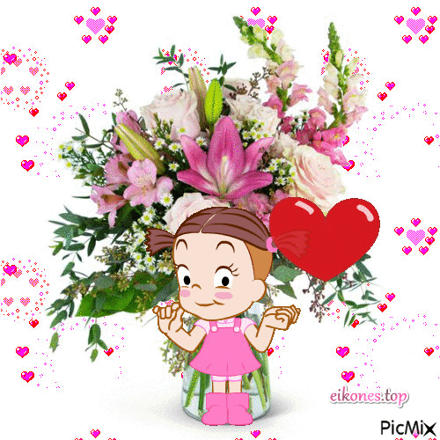

Dear Friend,

I decided to do a little research for this year’s Father’s Day Blog.
My inquiry was informal and
with people I knew.
The age range was 14 to 84 with
every decade in between represented.
I decided I would use my subjects’ words
to give honor to fathers for this Father’s Day Blog .

I asked those in the study,

“What three words describe your father?”

The answers were remarkably insightful; they revealed
a true understanding of their fathers as well
as how their fathers appeared to others.

I then went through my research notes and
circled the qualities that seemed to be repeated most often.

The results became

“The Beloved Father.”

The words most mentioned were
“kind, supportive, good-looking, honest,
calm, cool, collected, wise,
dependable, fun, loyal, and a role model.

Supportiveness was mentioned repeatedly.
And I thought how wonderful that these once little ones remembered being boosted by their father’s shared “wisdom and kindness.”
Being a role model, often mentioned, encompassed a “strong and calm, cool and collected, and very kind” person.
As you might suspect, I really loved reading these heartfelt comments.

One of my favorite descriptors was honesty.
How appreciated to come home to your family world
and know a loving father will give you profound truths.
In a world that gives many opinions that often vary,
there stands dad who is always honest in a supportive way,
thereby leading his child in the right direction.

The people in this study repeatedly
defined a good dad as being
“responsible,” “hardworking,” and
“loyal to his family.”

As children of these fathers, they all
felt loved and appreciated.
They described their fathers as solid
people who were “reliable,” and “loyal.”

Some in this study mentioned that
their dads were good looking,
inspiring, and intelligent. All these
wonderful character traits
added up to the most repeated term
in this study: a role model.

Perhaps every word mentioned referred
to a good "role model."
What can be better than a father
who is honest and caring,
supportive and selfless, yet
wise in manner? Not much!

All the words mentioned showed a
nobility of character worthy of being
a son or daughter’s role model.
A role model who affects who and what
we become and the people we allow into our lives.

I think those in this study used words
I would note to describe my own father;
he was hardworking,
loved his family, and valued education.

So, to all the Fathers out there,
please know your children will always
remember what you gave
to them as individuals,
love you for the “gift of you,” and
will carry the specialness you gave to them
throughout their lives.

Have a Happy Father’s Day, wonderful dad,
and always know how appreciated you are!

Much love,
Helene
June, 2021

